1.Get me the IP address of a particular domain (guvi.in). How do I find my CPU/memory usage of my server?. Test the connectivity between 2 nodes?

Option1:

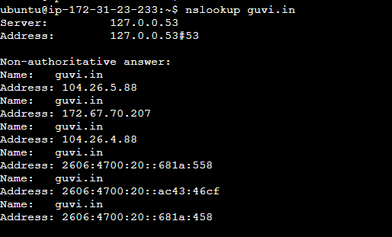

Option2:

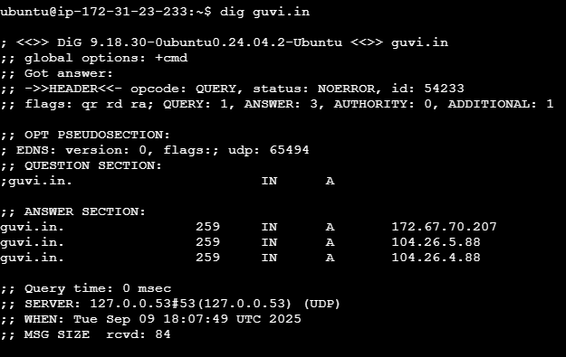

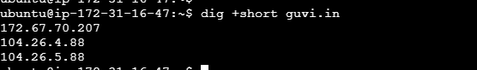

To check the CPU and memory usage of the server.

Free -h

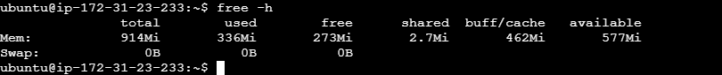

Top

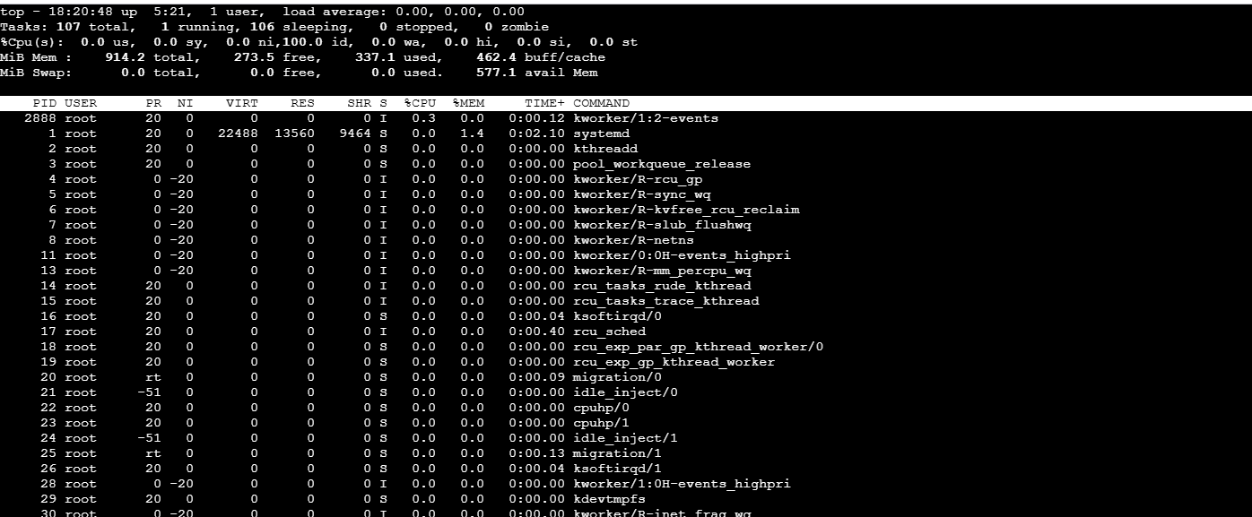

htop



Test the connectivity between 2 nodes?

From server 1 to server 2

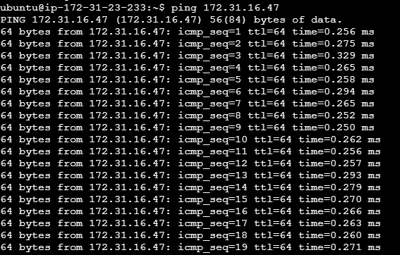

From server 2 to server 1:

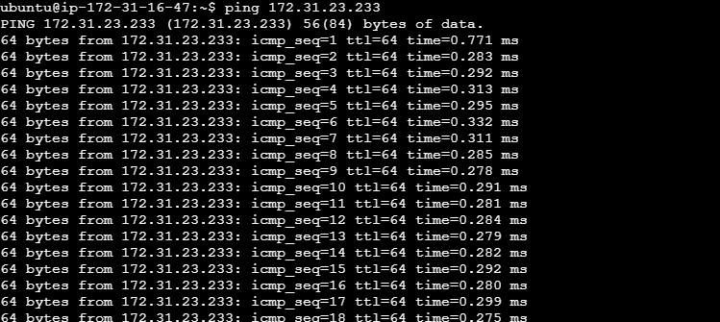

2.I have deployed an application in guvi.com:9000, and logs show my app is running, but I’m unable to view the page. Check whether my port is open or not ?

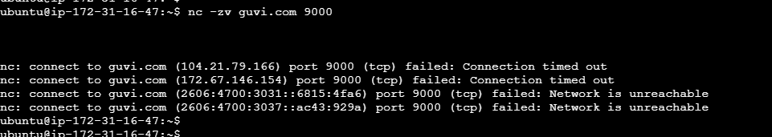

Trough ip

